Setting up the Voyager ArcMAP Add-in with ArcGIS Desktop

To set up the Voyager ArcMAP Add-in, go to the **${install.dir}/app/esri/addin**folder.

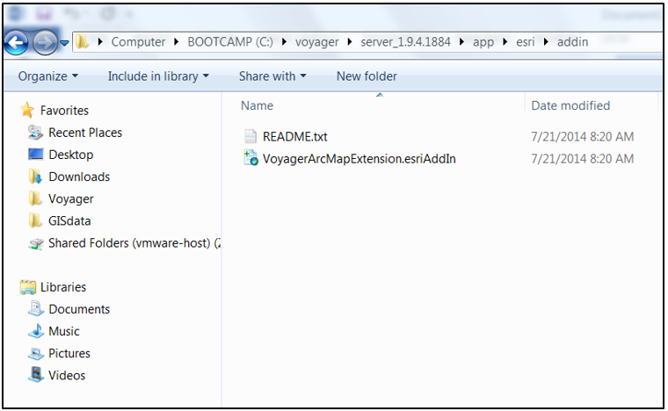

* Copy the *VoyagerArcMapExtensionesriAddIn* file to the computer where **ArcGIS Desktop** is installed
* On that computer, double-click the *VoyagerArcMapExtensionesriAddIn* file and click **Install Add-in**

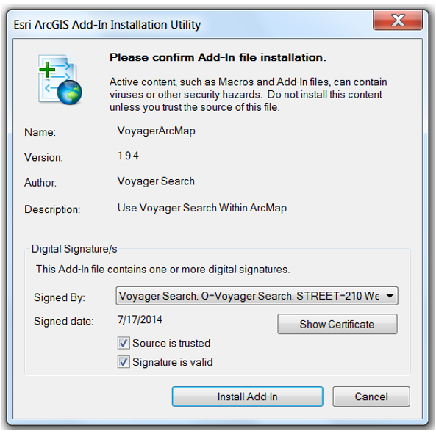

* Next, Open **ArcMap**

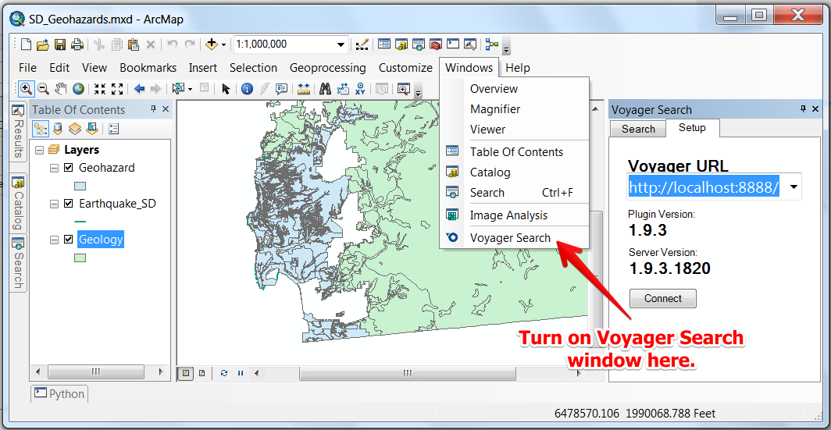

* Select **Voyager Search**from the Windows menu to open up Voyager and begin searching